Your paper title here

Supplementary Material <progressive number here>

Author1, Author2 … and AuthorN

General Guidelines for Tables and Figures:

- Clarity and Conciseness: The caption should clearly explain what the table or figure shows without being overly verbose. The reader should understand the key point without needing to refer extensively to the main text.
- Stand-Alone Information: The caption should be able to stand alone. A reader should be able to comprehend the content and relevance of the table or figure without needing to read the article’s full text.
- Contextualize Data: Contextualize Data: Summarize the main finding or pattern. For example, if the figure shows a trend, briefly state what the trend is in the caption. Remind the reader about context where the data is from, and the sample.
- Avoid Repetition: Don't repeat information already conveyed in the title of the table/figure or the text. The caption should add value by interpreting or providing additional context.
- Abbreviations and Symbols: If you use abbreviations or symbols, they should be explained in the caption or noted in the table/figure’s legend.
- Be Consistent: Use consistent language and style across all table and figure captions. This includes consistent tense, formatting, and terminology.

On the footer of the second page, edit the doi number for your article (figure 1).

Figure 1
Example on how to generate your article’s doi number form your submission page

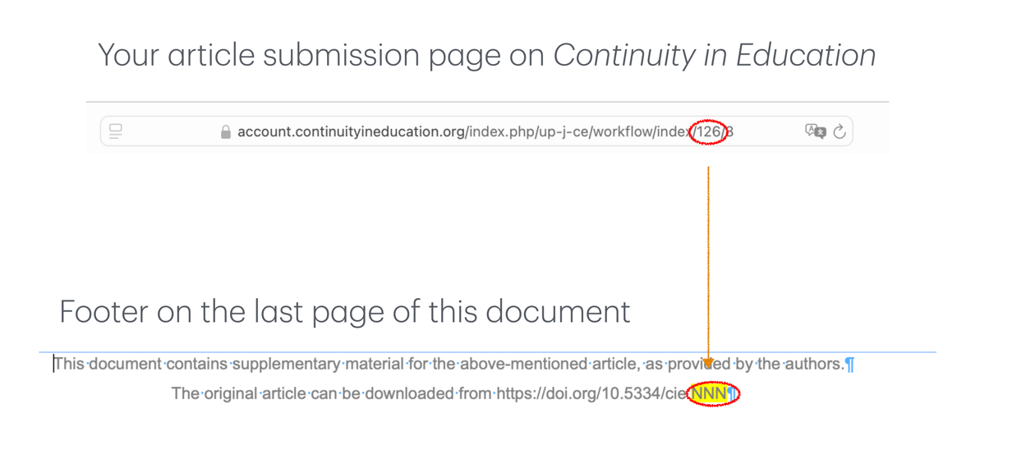
In this example, we extract the last part of your doi number from Continuity in Education submission page of an article (here 126). We then insert the number on the last part of the full doi in the footer from the second to last page of the present document.

The final doi number for the article will be: https://doi.org/10.5334/cie.126
(please notice that the link will only become live after the publication of your article).

Table 1
Overview of the demographic characteristics of the study participants (N = 200), including age, gender, and education level.

Column Head | Column Head | Column Head | Column Head | Column Head
Row Head | 123 | 123 | 123 | 123
Row Head | 456 | 456 | 456 | 456
Row Head | 789 | 789 | 789 | 789
Row Head | 123 | 123 | 123 | 123
Row Head | 456 | 456 | 456 | 456
Row Head | 789 | 789 | 789 | 789

Note. Values are presented as percentages and means with standard deviations where applicable.

Figure 1
Trends in Students Academic Performance Over Time

Trend in students' academic performance scores from 2016 to 2020. The green graph represents the mean score of students' self-assessments (N=167), while the orange graph represents the mean score of teachers' assessments (N=8).

